

**SUMMER TRAINING REPORT**

On

**Web Development**

Industrial Training and Certificate

Submitted in partial fulfilment of the requirement for

Graduate Degree in Computer Science and Engineering

At

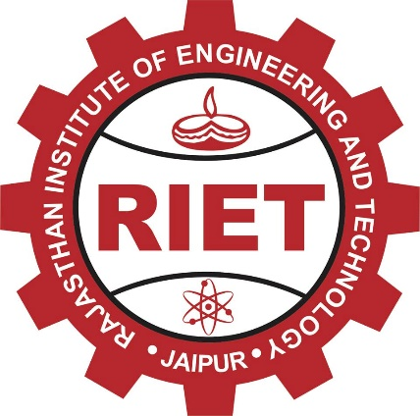

**Submitted by:** **Submitted to:**

Vritika Jangir Mr. Dinesh Swami

18ERECS089 Assistant Prof.

Department of CSE Department of CSE

**Rajasthan Technical University, Kota, Rajasthan**

**Session 2021-2022**